- There are multiple level user to database
  - User ---- DNS --- Web --- Application --- DB
  - At user’s browser level, caching happens. Means browser store the DNS information so that next time it’ll not have to request for resolving the domain.
  - At Web layer, CDN remains. Lets assume you want to serve some static files keps in S3 bucket.
    - So, first when you get the file, store it in a place and serve those files when required without going to the S3 bucker.
    - This is done with CDN. (Content Delivery Network)
  - At Application layer, you can use Redis, Memcached or some other caching tools so that you’ll not have to make DB calls multiple times to fetch the same data.
  - Even at DB layer you can do caching.
- DNS
  - When a user requests a website, their system or browser queries DNS servers to translate the domain name into an IP address.
  - Caching these results means that repeated requests for the same domain are resolved faster, reducing the need for repetitive network looks up and improving overall browsing efficiency.
  - This is particularly beneficial for reducing latency and enhancing user experience by avoiding delays in domain resolution.
- Web
  - Accelerate retrieval of web content from web/app servers.
  - Web caching enhances performance by storing copies of frequently accessed web pages, images, and other content.
  - When users request content, the cache delivers it quickly without needing to retrieve it from the origin server, which reduces load times and server strain.
  - This not only speeds up content delivery but also reduces bandwidth usage and server costs.
  - This is typically implemented using CDN.
  - Web caching is crucial for improving the responsiveness of web applications and ensuring a smoother, faster user experience.
  - What it caches? : Static files (images, CSS, JS), HTML pages, Public API responses

- Application caching (Redis, Memcached, ..etc)
  - What it caches? : DB query results, User sessions, Computed objects, Aggregations, Authorization info
- Simple difference between CDN and Redis/Memcached/ (other application service) is:
  - CDN caches the things between client and server
  - Redis / Memcached cache data inside your backend, before hitting the database.

- Cache terminologies
  - Cache HIT and Cache MISS
  - Cache eviction policies: LRU, LFU, FIFO, TTL bases
  - Cache expiry and TTL
  - Cache loading strategies: Lazy loading, Eager loading or Cache warming
  - Cache size and capacity
- F

Caching in Spring Boot
- There are 2 annotations.
  - @EnableCaching
    - It’s a class level annotation.
    - It should be written in a component.
    - Avoid writing this in the main method’s application class, otherwise it’ll make caching mandatory.
    - By default it setup a CacheManager and creates in-memory cache using one concurrent Hashmap.
  - @Cacheable
    - It’s a method level annotation.
    - Its used with a method whose response has to be cached.
    - Spring boot manages the request and response of the method to the cache that is specified in the annotation attribute.
    - It just see the cache, if the data present then just return that.
  - @CachePut
    - It is also a method level annotation.
    - It is used to update the cache after invoking the method.
    - By doing this, the result is put in the cache and the method is executed.
    - It has same attributes of @Cacheable annotation.
  - @CacheEvict
    - It is also a method level annotation.
    - It is used to remove the data from the cache.
    - When the method is annotated with this annotation, then the method is executed and the cache will be removed/evicted.
- Example
  - 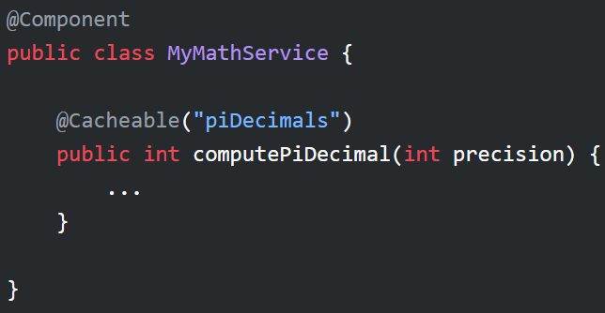
- Cache is just like a HashMap which stores in key-value pair.
  - Normally redis stores data like this
  - Lets assume the method is
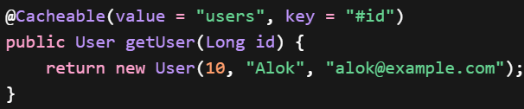
  - Here, the “value” field inside @Cacheable (not the value inside redis) represents the method (getUser)
and “key” field inside @Cacheable represents the argument.
  - These both combined makes the key of Redis, and the value of Redis against this key will be like
  - So, “value” field inside @Cacheable is not the value of Redis cache.
  - Instead of value, you can write cacheNames as well. Both are aliases of each other.
- F
- F
- F

- Implementing Redis caching in spring boot application
- First create a config file and annotate it with @EnableCaching , because you shouldn’t write this annotation in the main method’s class.
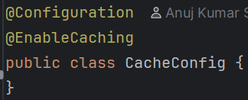
- Annotate the cacheable method with @Cacheable
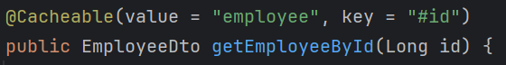
  - Note that # , without this it’ll not take the value of the argument.
  - Here, Redis key will be like: employee::3 (if id = 3)
  - If you want to be more specific, like if the method has more arguments and you want to be specific with more arguments then
it’ll create keys like: employee::[5, alok] (id = 5, name = “alok”)
    - Its SePL query, { } means list.
    - It’ll become a composite key. (id, name) (Object composite)
    - It is safer to use.
  - Also, another method of writing this is
it’ll create keys like: employee::5:alok
    - Its also composite key (String composite)
  - If you have a lot of filters (to be passed inside key field) then you can use a custom key generator function and pass like
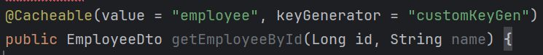
    - It sends all the arguments to that customKeyGen method.
  - One more method is hashing, you can create a token and store that as the key in redis cache.
    - Either you can use custom key generator method where you’ll return the hash.
    - Or you can use SePL language directly
- Annotate with @CachePut annotation
  - #result.id because the return type of createNewEmployee method is EmployeeDto,
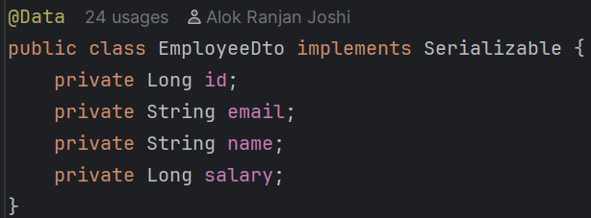
even if it is private and the getter method is getId(), so instead of #result.id we should write #result.getId(), but NO.
Internally SePL invokes the getter method like #result.getId() when we write #result.id
  - Now, whenever we’ll create a new employee or update an employee, it’ll write the latest data into the cache after the method is executed.
  - NOTE: it’ll store the data in Cache only if the method is executed successfully, in case of any exception it doesn’t store the data in cache.
- Annotate with @CacheEvict annotation
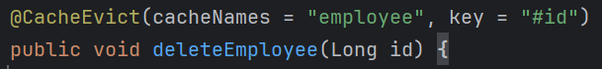
  - It’ll delete the data from the cache if the method deleteEmployee is executed successfully.

Internal working of Caching in Spring Boot
- There is an interface CacheManager which has to be implemented by the cache provider, in our case it is Redis
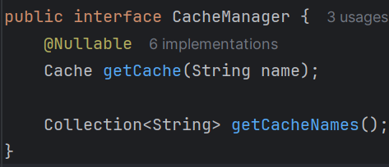
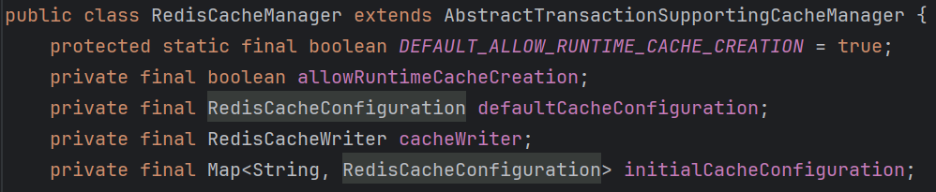
(AbstractTransactionSupportingCacheManager extends CacheManager)
  - defaultCacheConfiguration : it is to set different types of configs like prefix, expiry, reset the expiry if the cache hits again ..etc
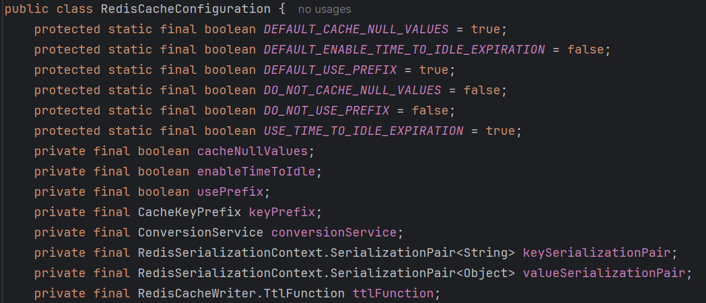
  - initialCacheConfiguration : it is to set the default configurations for different caches, like for “employee” one type of configuration, for “department” another type of configuration
    - 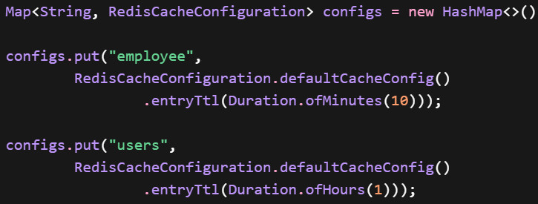
- This CacheManager’s bean is auto-configured by spring, if you want custom configuration then you can create the bean of RedisCacheManager.
- This is how you can create custom RedisCacheManager bean
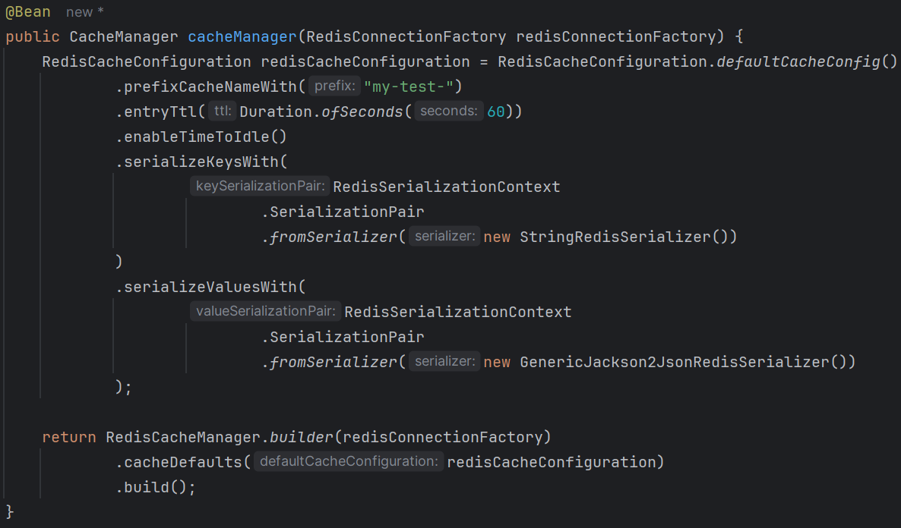
  - RedisConnectionFactory (implemented by LettuceConnectionFactory) creates and manages connections that Spring uses to talk to Redis.
    - Without this spring cannot execute GET, SET, DEL, TTL, ..etc.
  - RedisCacheConfiguration is the one which are (mentioned in the previous page), it adds the default configurations for the redis cache manager.
  - serialize are for the type in which keys and values will be stored in redis db.
- 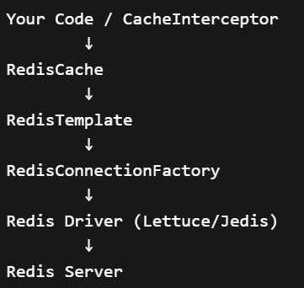

- Internal Flow
- CacheAutoConfiguration (auto-configuration class)
  - CacheManagerCustomizers, CacheManagerValidator,
  - CacheManagerCustomizers contains list of CacheManagerCustomizer
  - CacheManagerCustomizer takes generic (T extends CacheManager), it contains a manager customize which takes CacheManager or one of its sub classes as its argument.
  - So, if we create CacheManager bean by our own, then it’ll take that CacheManager bean instead of the default one.
  - Now the question is, we create only one bean of CacheManager, then how it’s a list
  - So, this is not list of CacheManager itself, its a list of CacheManagerCustomizer
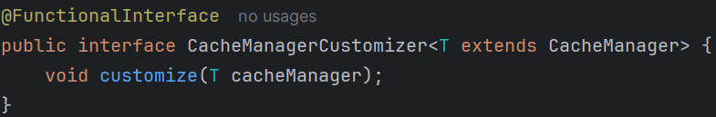
  - We can have multiple CacheManagerCustomizer
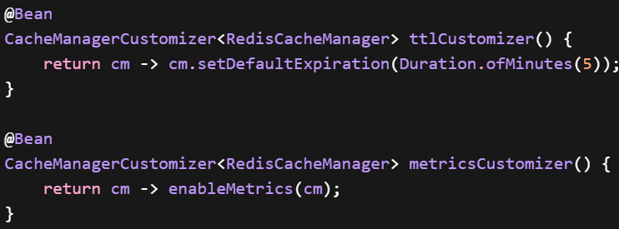
- F
- F
- F

- Spring Boot is built on this philosophy:
“The framework owns object creation,
developers only tweak behavior.”
- 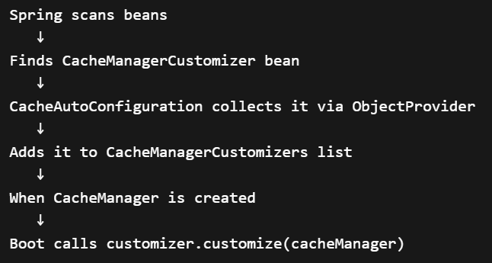
- Customizer interface is to customize a already created object with some different parameters. Consider the below example
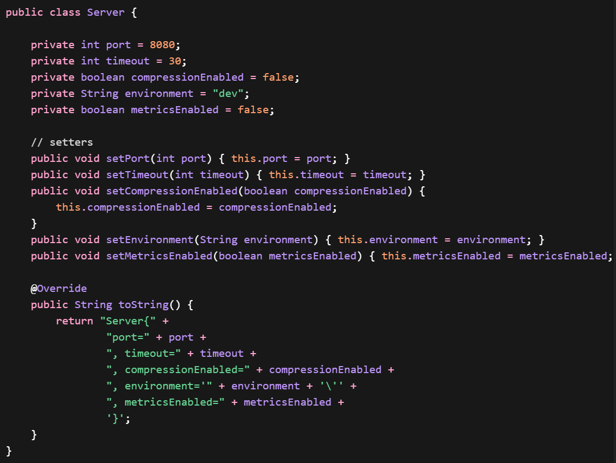
  - 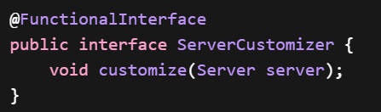
  - 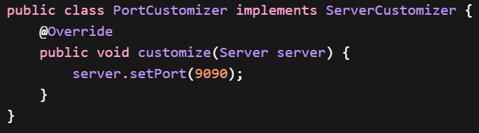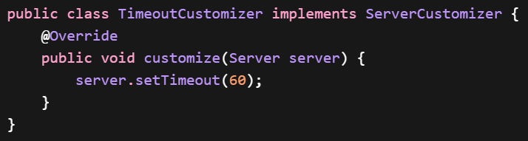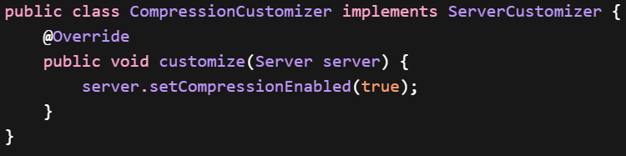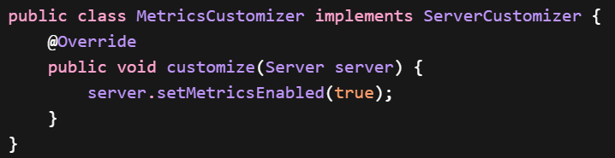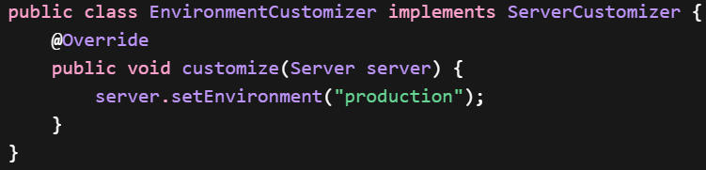
  - Customizer takes the actual object that has to be customized, and customize its params so that you need not change the properties of the object manually.
  - 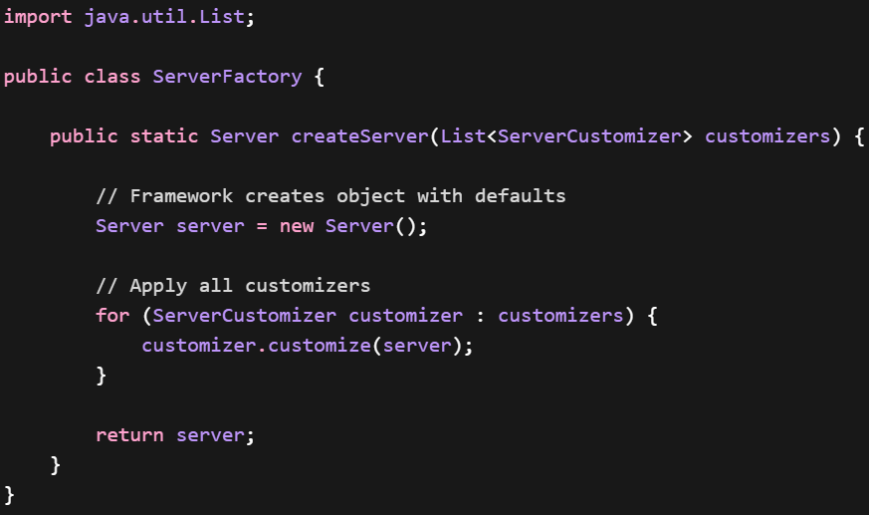
    - Server factory takes list of customizers (here ServerCustomizer; because it is the customizer interface of the Server class) and create an object and change its values according to those customizers.
    - You can have multiple customizers for multiple properties of an object.
  - 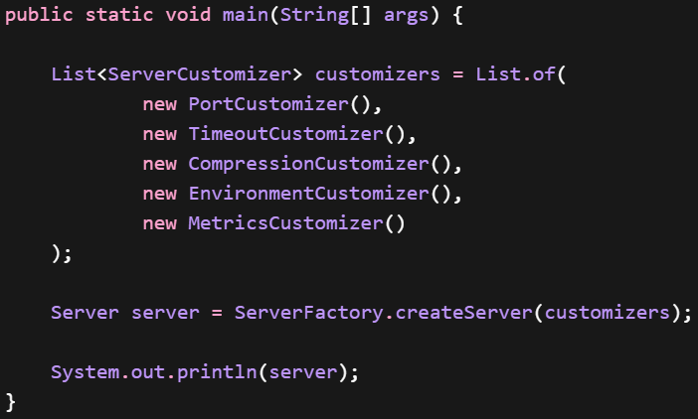
    - Now, you’ll take all the customizers (that you need) in a list and create the object and call the customize method of all those customizers to configure your created object.
  - HENCE; Customizer doesn’t help in creation of an object (bean in spring boot), rather they changes the properties of that object after the object being created.
- In spring security, when we have to configure the formLogin part, we can directly pass Customizer.withDefaults() which by default set the properties
instead we had to write like the below

- 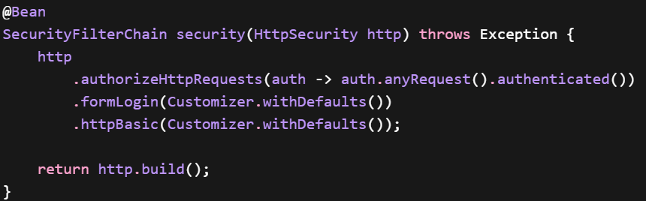
  - This Customizer.withDefaults() also returns a Customizer object.
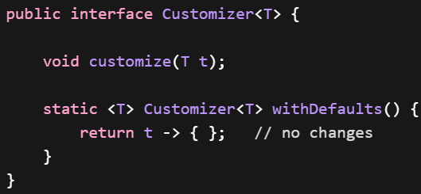
  - formLogin() takes customizer and customize the created object according to that.
- Ff
- F

